ChainFlux
Project Requirement

Project Title & Headcount:
S No | Team | Project Title | Headcount Aligned
1 | A | Binary Options Trade | 6
2 | B | Securitization of Loans | 6
3 | C | Crypto Mutual Fund on Smart Contracts | 6
4 | D | ETH Cash Wallet | 7
5 | E | Inventory Management System | 4

Platform/Software Required:
Front End | Angular JS
Back End | NodeJS

Time Estimation
Milestone | Planned Start Date | Planned End Date
End to End Product | 20-Mar-18 | 9-Apr-18

Team –A | Binary options trade
Introduction:
In the beginning of binary options trade era, High/low options trade also called as call/put options trade was a famous type of binary options trade. And it is still one of the widely recognized binary options trade. In this type of trade users bid money on asset by selecting high or low option as per their wish. It is done by predicting whether the asset is going to Increase or not at the end of the expiry time of the bid from the starting time (strike time) of the bidding.
Proposed Project:
As we explored, High/low options trading is extremely easy because, these two options results only two possible outcomes.
Here we have decided to add one additional feature to show the star performers to the users by introducing a leader board this shows the maximum bid winners. Traders can make a team with these star performers in the Leader board. This feature can motivate new users to bid. And they share their profit if they win the trade.
Conclusion:
Since the explosion of public Interest in High/low binary options trade, Binary options become very exciting. More and more new users are investing every day. Team forming feature is also included here, so that it can motivate investors to invest more.

Flowchart:
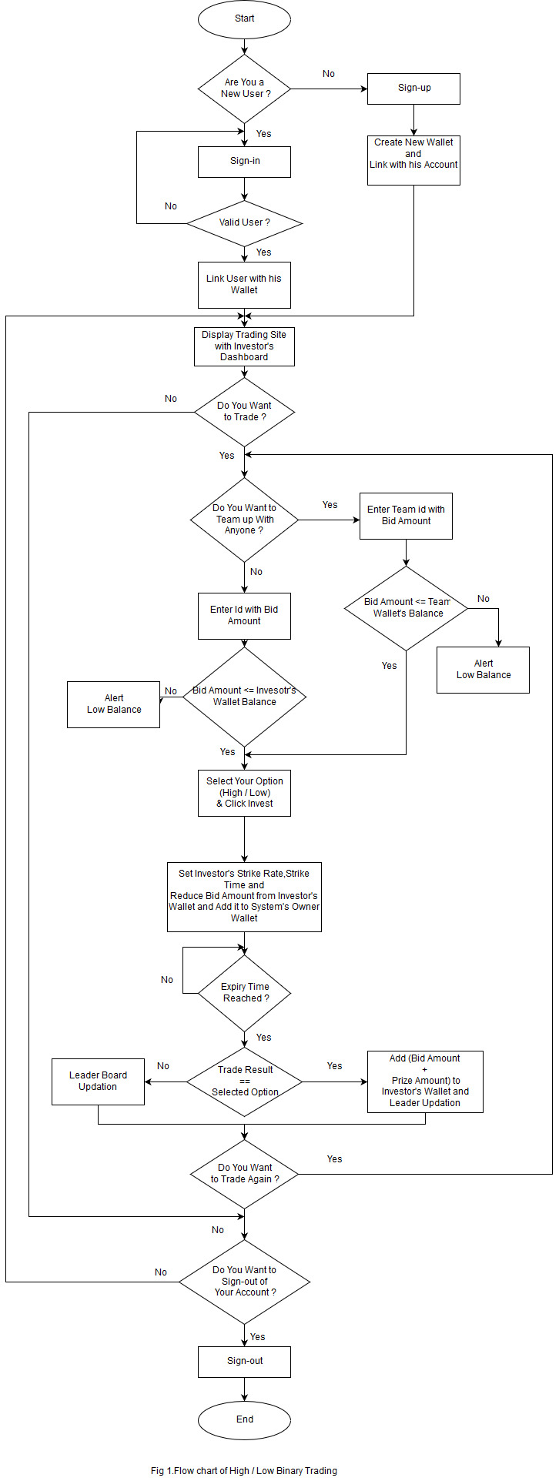

TEAM -B | Securitization of Loans

Abstract
Securitization is the process of transformation of non-tradable assets into tradable securities. It involves the repackaging of individual guaranteed loans made by financial institutions into pools of varying maturities for resale to Special Purpose Vehicle (SPV) and investors. Each securitization contract is associated with pool of loan contracts (securitization Pool) and a SPV. Formula definition used to filter or identify the loan contracts that forms part of the securitization pool. The details and documents of a Securitization Product have gotten from the borrower and Special Purpose Vehicle. Once the contract has been signed after the legal verification, the financial institution becomes the service provider for borrowers and SPV. It transfers the monthly payments / interest / charges / Fees / Prepayment / penalty charges directly to SPV as per the agreement. Securitization transactions may include credit enhancement (designed to decrease the credit risk of the structure) provided by an independent third party in the form of credit or guarantees. Trustee is appointed to represent the investors' interests in a securitization. They ensure that the securitization operates as set forth in the securitization documents, which may include determinations about the servicer's compliance with established servicing criteria. Underwriter is one of the third parties who purchase the remaining securities from the SPV then they sale it to the investors, the investor got the monthly payment from SPV based on the information in security certificates that issued to investors.

Flow Chart:
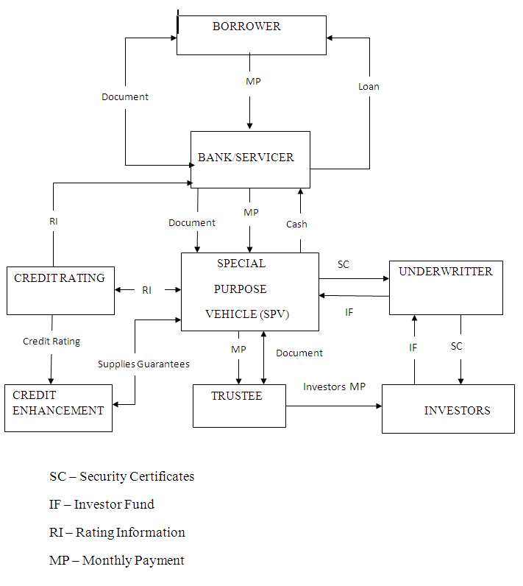

TEAM -C | Crypto Mutual Fund on Smart Contract
Introduction
The development of block chain technology and the rapid growth of the Crypto currency market, new opportunities appear consistently in the field of Investment. The traditional economy changes its form, new values arise in the digital "world" and a significant role in these processes is played by decentralized technologies, in which Crypto currencies and digital tokens play a critical role.

Abstract
Crypto Mutual Funds are created from the investments of multiple investors that pool up their capital to the Crypto buy-and-hold funds. The Crypto assets shares will be buying based on tokens. In return, they are given a profit in the fund (usually in the form of “tokens”). The profit tokens can also be Exchange as Ether.

Tokenized Mutual Fund
There are various types of funds that already invest in Crypto assets (Hedge Funds, Classic ETFs, Closed-End Funds, and Venture Capital Funds). Independent and still a small segment of the market are tokenized funds. The key phenomena here are that investors acquire a share calculated by reference to the assets in the fund, implemented through tokenized smart contracts.

The Initial Coin Offering (ICO)
Starting a crypto fund is similar to offering the profit share to the investors in a company. Your Initial Public Offering (IPO) transaction forms the basis needed to attract investors towards your company. Therefore, you need to prepare a white paper agreement that discloses your project concept, duration, distribution of virtual tokens between you and the investors, and the 4goal of your ICO campaign. ​Tokens are produced on the Ethereum platform based on ERC-20 standard.

Flow Chart:
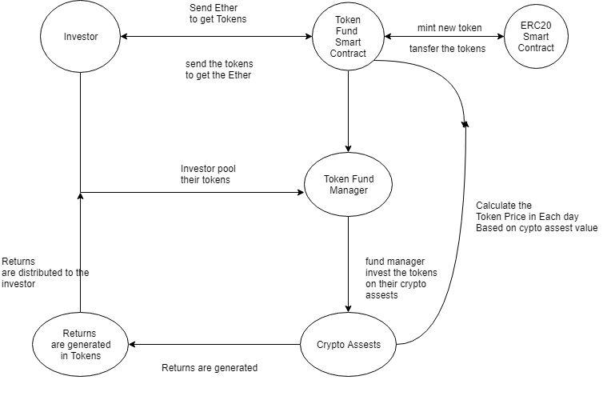

Work Flow
- First Investor has to buy the tokens so they to spend the specific Ether to buy the tokens using Token fund smart contract. The ERC20 token contract is linked with Token fund smart contract for continuously mint the tokens.
- The Investor has to invest the Tokens (Token fund) on Crypto Assets through the Token Fund Manager to buy a share. The Token fund managers have all the details about the Crypto Assets.
- The Fund Managers are responsible for pooling the tokens from the Investor and allocating proper shares for them.
- The returns are generated in the form of Tokens to the investor. The investor can use the profit tokens for reinvestment in the future (or) can exchange the profit tokens to ether.
- The Tokens value is get changes everyday based on the crypto assets rate.
Technical Solutions - Components
The technical solution for The Token Fund consists of three main elements:
- User-facing website
- Backend server for asset management
- Smart contracts on Ethereum Blockchain
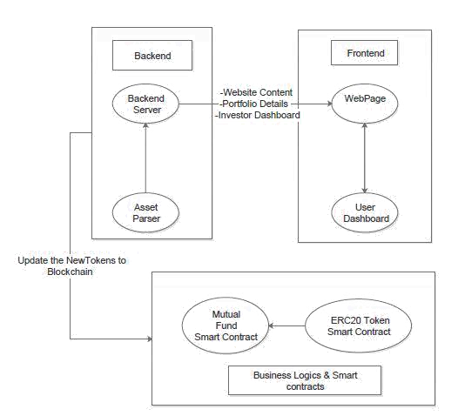

Asset Management
All the fund's assets are located at publicly accessible through Google Sheet. Every 12 hours asset parser component calculates current portfolio value and fund performance using API of popular Blockchain explorers in order to receive balances of fund wallets and information from the token smart-contract. Fund performance and portfolio composition from the table are graphically displayed on the front page of The Token Fund. The client who wants to make investments and purchase TKN must undergo the KYC procedure ("know your customer"), for which identification documents are needed. The KYC procedure is carried out through the website interface. In the dashboard an investor is able to create a wallet and back up the keys for it. An address provided by an investor or newly generated one is used by the service to issue new tokens.
Backend Service
Backend service is responsible for storing wallet addresses for Investors and for interacting with Ethereum Smart Contract. It takes current token supply from TKN contract and calculates last token price based on the fund portfolio asset value. After that, it acts as a company by publishing the latest price of the token on The Token Fund contract. The backend is also responsible for initialising new token issuance once it gets investment in Ethereum through the dashboard.

Smart Contracts on Ethereum Blockchain

The business logic of The Token Fund is controlled by two smart contracts on the Ethereum Blockchain: one is a token that stores the balances of investors in the fund (ERC20-TKN contract), and another is responsible for issuing new tokens in exchange for invested money (The Token Fund contract). TKN contract is based on the ERC20 standard token contract with an extra function that allows new token emission. This function is only accessible by The Token Fund contract.
Investment Flow
A regular way of investing requires sending bit coin or ether to the personal investment address available in the dashboard. After receiving an investment, the backend triggers the function on The Token Fund contract that calculates the number of tokens the investor should be distributed based on the current price of the token. After that, the backend service executes issuance function on The Token Fund contract to mint new tokens for a new investor.

Advantages:
- Ethereum smart contracts enable a very transparent and secure way of reward-sharing among the token holders.
- Investing in a crypto fund is that the Crypto currency is going to be the Currency of the future.
- Investing crypto funds to become safe to build your assets. Because mining is more complication in mining algorithms.
- A crypto fund provides higher profit, because Crypto currency value changes day by day.

TEAM -D | ETH Cash Wallet
Prologue:
“Ethcash Wallet” is the intellectual project aims to digital money transfer and address such inefficiencies by introducing a solution combining smart contract on the Blockchain to drastically transform.

Objective:
The mission is to bridge the gap between those with access for finance and those without, eliminating borders, intermediates and prejudices.

Technology Stack:
Consummately, A Blockchain relies on a digital and distributed ledger, which performs in a transparent environment without the need for a trusted authority to validate transactions. It acts on blocks and thus yields integrity and consistency make the users to rely on it. The persistent behavior of inter-connectivity over blocks persuades users to bank on correspondingly, ensures entanglement on the inveterate hackers.
Peer to Peer lending Business Model:
Peer to peer lending platforms enable borrowers and lenders to connect in an online marketplace, directly, eliminating the role of an intermediary. The loan application process is generally straightforward facilitating faster decisions and higher ratio of approvals. The loan status and terms are clear and transparent establishing confidence in the parties involved. Lenders can theoretically shop for their ideal borrower, with the most attractive loan terms. Lenders also have the option to fund all or part of a loan, so they can diversify their loans and spread their risk across a range of borrowers. The interest rates offered to borrowers tend to be more competitive due to the credit availability, and similarly lenders can benefit from more attractive returns that typical bank deposits, thus satisfying both parties involved. The platform facilitators earn fees for providing this direct connection between borrowers and lenders, and a fair and transparent network in which they can service one another.

Collateral Management:
The prime way to lend based on collateral, get interest and invest in mutual funds is done by using Blockchain technology which attacks a traditional business model with a lower-cost solution and overtake incumbent firms quickly. The “lend based on collateral” is all about like transaction using collateral (asset). The estimating value of collateral would be done by collateral management for prevailing market price of the collateralized crypto assets from variety of sources that makes the parties to arbitrate on estimation. As the assets are dynamic and may fluctuate in price, the smart contract will reassess the valuation to match the terms of the agreed smart contract. Monthly payment requirement is up to the endorsement between lender and borrower. It could also be retained by mutual fund.

Mutual Funds:
Mutual fund pools the money and connects network from fund managers to transfer agents and distributors. After mutual fund realizes the dividend, shares to investors. All of these services will be paid for with the utility token as ERC20. The token enables users to make faster, more affordable transactions and access lending from any country.
EPILOGUE:
Using Ethcash wallet, a crypto token on the Blockchain, developed on the Ethereum platform, leads to lend and invest in a quick, pocket friendly and hassle-free manner. Payment transfers can be made worldwide near instantaneously, with minimal fees. This process is simple, the system is global and it’s accessible 24/7.

Flow Chart:
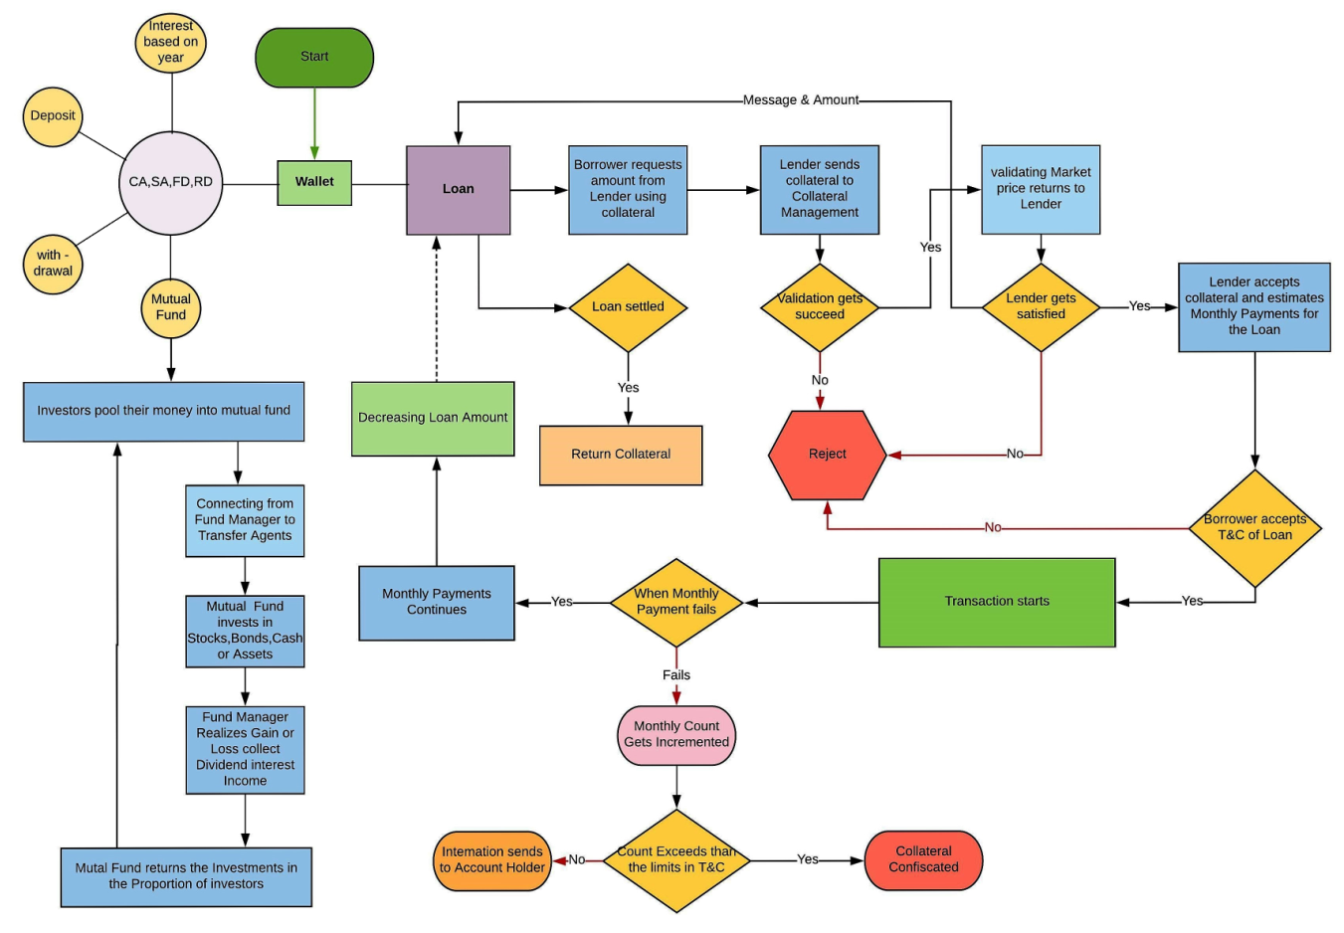

TEAM -E | Inventory Management System
ABSTRACT
Inventory Management System is software which is helpful for the businesses operate hardware stores, where storeowner keeps the records of sales and purchase. Mismanaged inventory means disappointed customers, too much cash tied up in warehouses and slower sales. This project eliminates the paper work, human faults, manual delay and speed up process. Inventory Management System will have the ability to track sales and available inventory, tells a storeowner when it's time to reorder and how much to purchase.
Steps:
- Admin signup and login
- Add product category
- Add product brand
- Order product
- Maintain invoice and out-voice
- Maintain account
- Purchase material for manufacture the product
- Stock management
Flowchart:
